Basic labs

1)

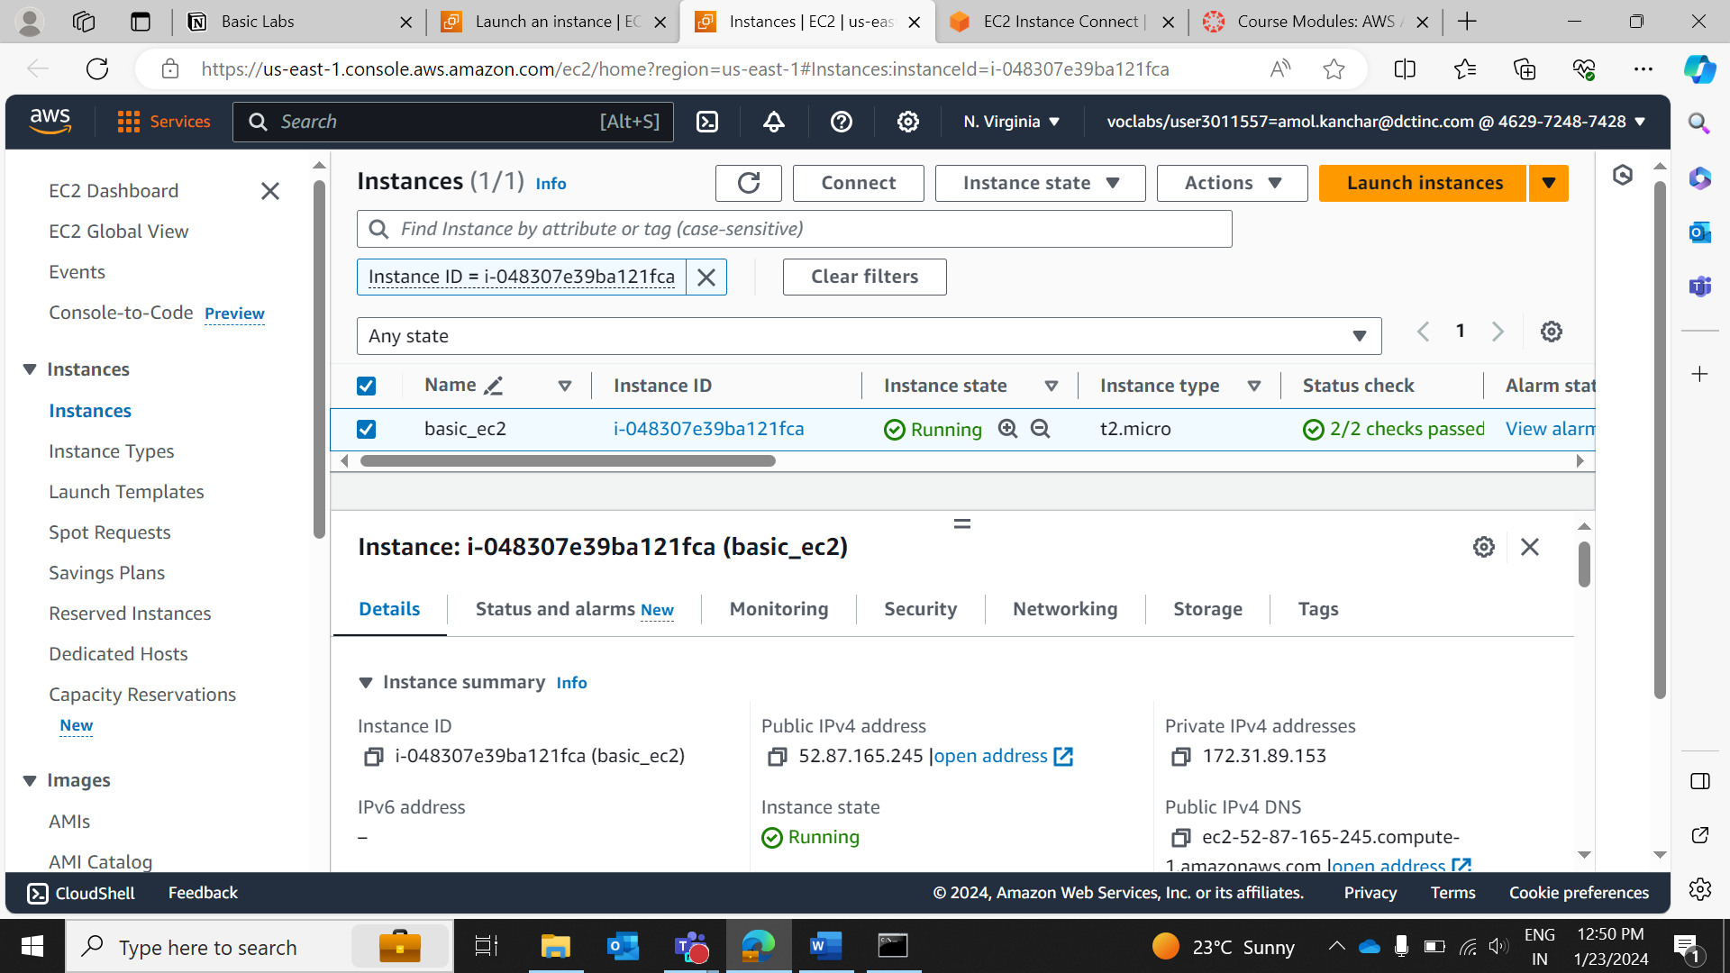

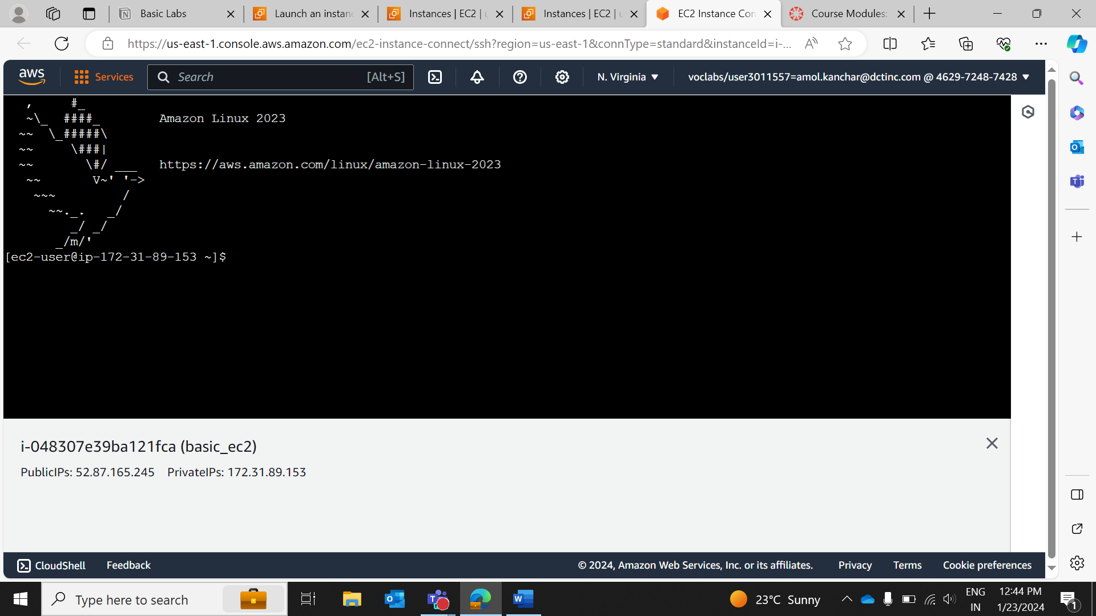

2)

